**Sura Ionospheric Heating Facility**

From Wikipedia, the free encyclopedia

[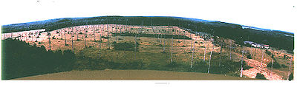](http://en.wikipedia.org/wiki/File:Sura-antenna.jpg)

View of antenna array at Sura site.

The Sura Ionospheric Heating Facility, located near the small town of Vasilsursk about 100 km eastward from Nizhniy Novgorod in Russia, is a laboratory for ionosphere research. Sura is capable of radiating about 190 MW, effective radiated power (ERP) on short waves. This facility is operated by the radio-physical research institute NIRFI in Nizhny Novgorod. The Sura facility was commissioned in 1981. Using this facility, Russian researchers studied the behavior of the ionosphere and the effect of generation of low-frequency emission on modulation of ionosphere current. In the beginning, the Soviet Defense Department mostly footed the bill. The American HAARP ionospheric heater is similar to the Sura facility. HAARP transmits much lower energy signals in comparison to Sura. The HAARP project began in 1993.

[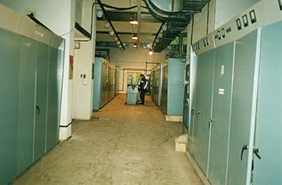](http://en.wikipedia.org/wiki/File:Sura-transmitter.jpg)

Transmitter room at Sura facility.

**Technical information**

The frequency range of the heating facility is from 4.5 to 9.3 MHz. The facility consists of three 250 kW broadcasting transmitters and a 144 crossed dipole antenna-array with dimensions of 300 m x 300 m.

At the middle of the operating frequency range (4.5 – 9.3 MHz) a maximum zenith gains of about 260 (~24 dB) is reached, the ERP of the facility is 190 MW (~83 dbW).